**ST. PETER’S NEWSLETTER**

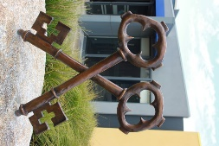

**2A Killeen Street, Sunshine South West:**

March 3 2021

Dear Families,

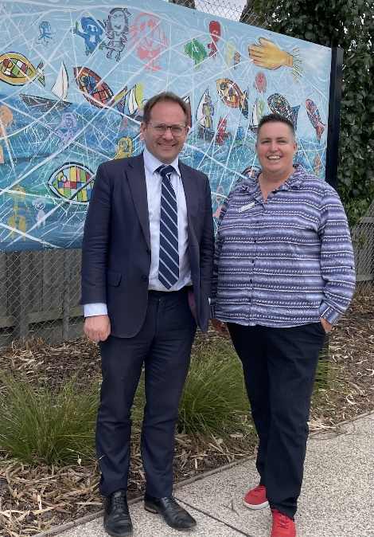I hope you’ve all had a wonderful week.  It was exciting to have a visit from our local Federal Member of Parliament for Fraser - Dr. Daniel Mulino on Monday.  Daniel was very impressed with our school and was pleased to meet our children at Assembly this week.

**School Closure**

A reminder that our school will be closed tomorrow, Thursday 4th and this Friday 5th due to the staff undertaking Professional Learning. We hope you all enjoy your very long weekend.

**Public Holiday**

Please remember that Monday March 8th is a public holiday in Victoria, so our school will be closed.

**Staffing**

I would like to thank Angus Edwards who has managed the office for the past three weeks while we have been finding a replacement for Helen.  We are very excited to welcome Ms. Leah Stringer to our administrative team.  Leah has been in the office this week and will officially begin next Tuesday.

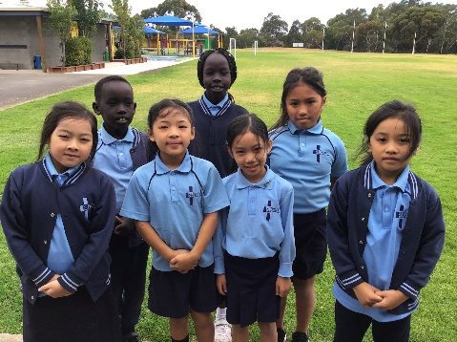

**Reconciliation**

Congratulations to Cindy, Kalia, Bella, Lual, Lucia, Jenny and Jessica who will receive the Sacrament of Reconciliation next Thursday March 11, at St. Paul’s Church.  I ask that you keep these children and their families in your prayers.

**PSGs**

Thank you for all of the parents/carers who attended their child’s program support group meetings last week.  Not all children have these meetings, but we appreciate that families who do, have been able to attend.

**Friday Sport**

Mr. Mogg received some lovely feedback from one of the teachers from Mother of God after Interschool Sport last week, who said, “Thoroughly enjoyed this morning. Your students were beautiful and the greatest of sports, and yourself and your team of staff were just a pleasure to deal with.”

This is the St. Peter’s Way!  Congratulations 5/6 students and staff.

**Congratulations**

Congratulations to Ms Elliser Pellisier who married Mark last Saturday. We wish them all the very best for their future together.

**Term 1 Dates:**

|  |  |
| --- | --- |
| **04/03/2021** | School Closure (Staff Conference) |
| **05/03/2021** | School Closure (Staff Conference) |
| **12/03/2021** | Interschool sport 5/6's Round 5 |
| **19/03/2021** | Free Dress Day (Easter Egg donation) |
| **19/03/2021** | Interschool sport 5/6's Round 6 |
| **01/04/2021** | Easter Liturgy @ 9.15am |

Enjoy your week,

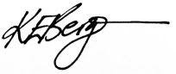

Karen Bergin

PRINCIPAL

**As a Catholic Community we respect the Wurrundjeri people, traditional custodians of the land upon which our school resides, and commit ourselves to reconciliation and justice for all in our community and nation.**

MAY OUR CHILDREN FLOURISH

We have zero tolerance of child abuse and all allegations and safety concerns will be treated seriously and reported in line with our legal obligations, our moral obligations and our school policies. Creating child-safe environments is a dynamic process that involves active participation and responsibility by parishes, schools, families and communities. It is marked by collaboration, vigilance and proactive approaches across policies, procedures and practices.